Experiment – 7
Question:
Create a Virtual Machine with 1 CPU, 2GB RAM and 15GB storage disk using a Type 2 Virtualization Software, using virtual box.
Answer:
AIM: To create a VM with specific hardware configuration.
SOFTWARE REQUIRED: Virtual Box, Host OS: Windows
PROCEDURE:
STEP 1: Open VirtualBox
Click Start → Oracle VM VirtualBox
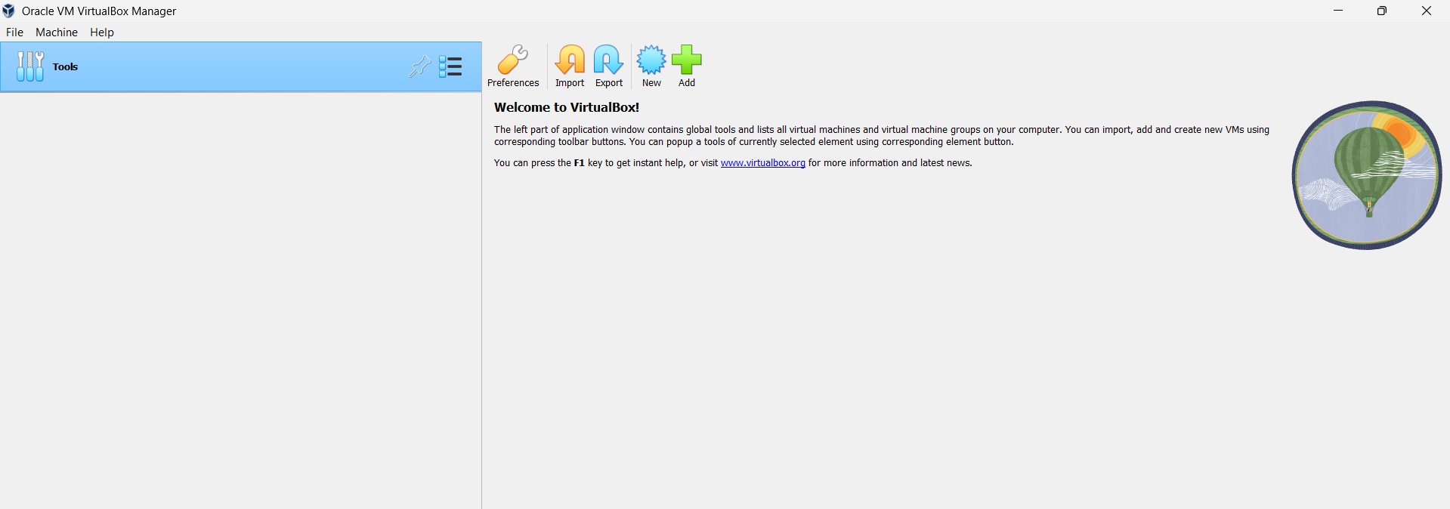

STEP 2: Create New VM
Click New
Name: Virtual Box Ex-7
Type: Linux
Version: Ubuntu (64-bit)
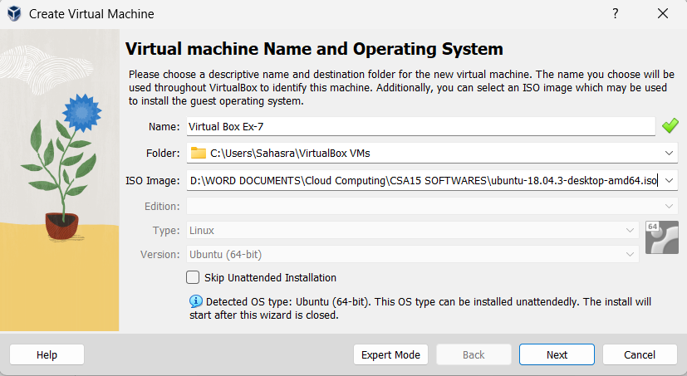
STEP 3: Select ISO File
Click ISO Image
Browse and select Ubuntu ISO
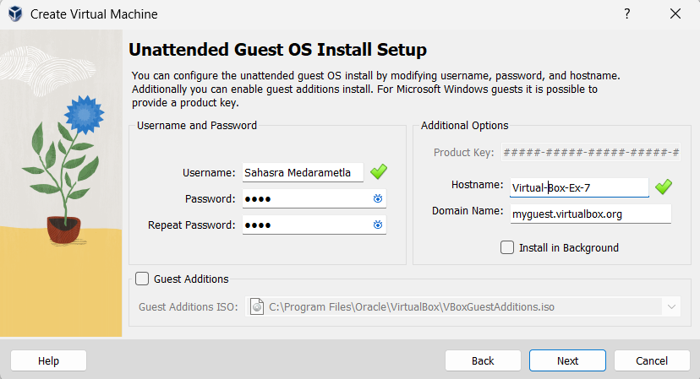
STEP 4: Set CPU = 1
Set Memory = 2048 MB
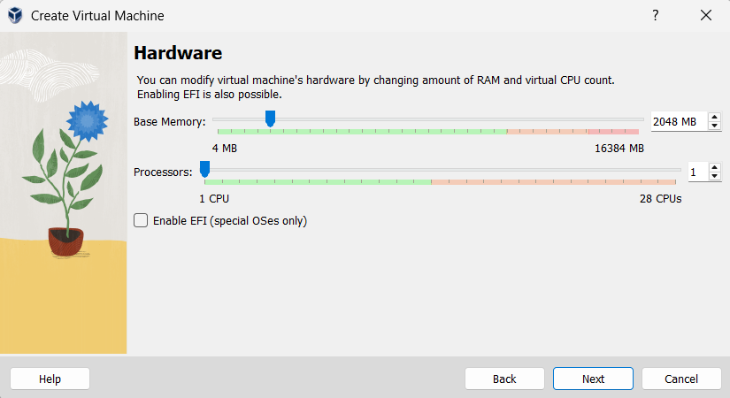
STEP 5: Set Disk Size
Verify disk = 15 GB
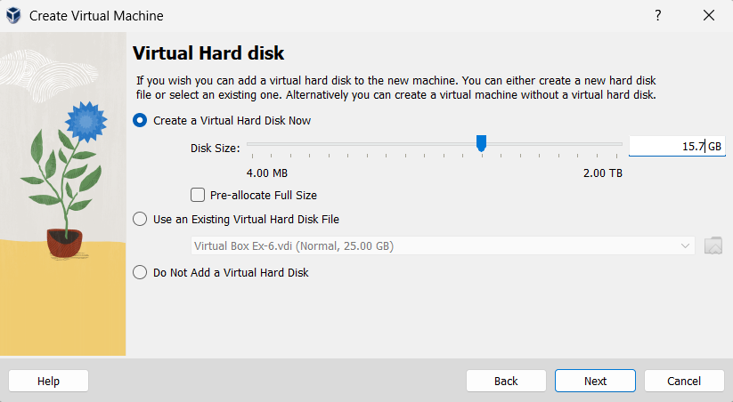
STEP 4: Finish Setup
Click Next → Finish
Click Start to run VM

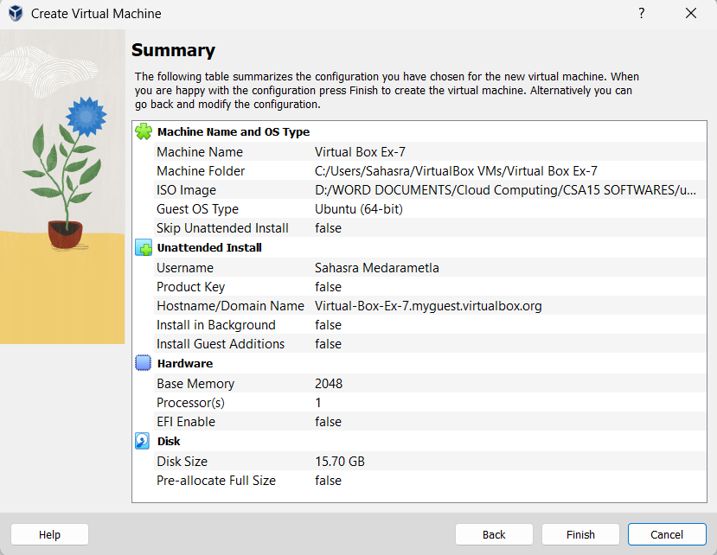

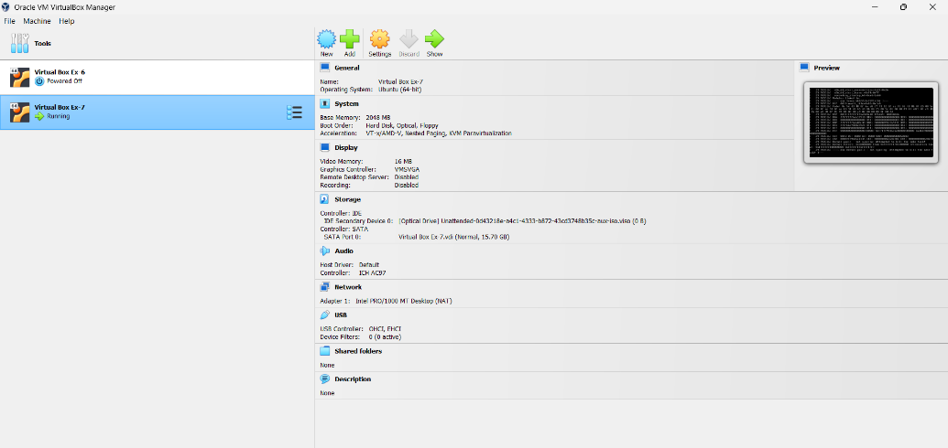

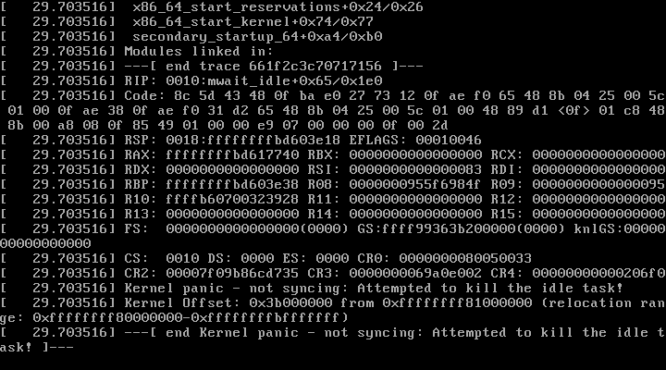

RESULT: VM with 1 CPU, 2GB RAM and 15GB disk created successfully.

